Detecting Malware Command & Control (C2), Beconing Activity in Security Onion
During my recent cyber defense analysis, I simulated and investigated potential post-exploitation Command & Control (C2) traffic using Security Onion.

Scenario 5 — Beaconing Behavior
Goal: Detect periodic C2 traffic patterns in network telemetry.

Steps Performed:
Attack Simulation:
A controlled C2 connection was established using Metasploit’s meterpreter payload between two virtual machines.
Network Monitoring:
Observed network activity in Zeek conn.log and Suricata alerts.
Used Kibana visualizations to examine traffic frequency and data size.
Findings:
Over 100 requests were observed from host 10.6.13.133 → 10.6.13.3 in less than two minutes.
The requests were uniformly spaced, with consistent packet sizes — a strong indicator of automated beaconing.
Suricata logs showed correlated alerts consistent with C2 or suspicious persistence communication.
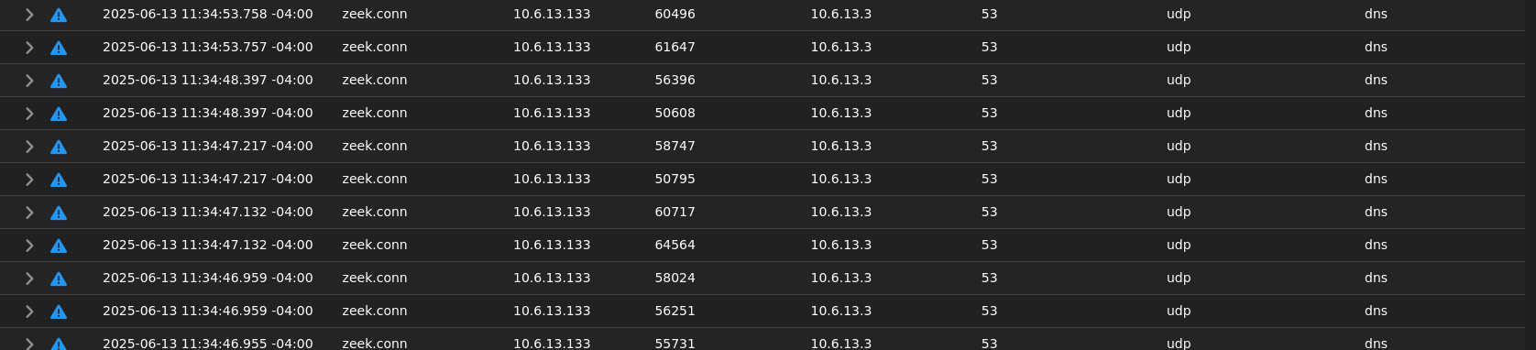

Analysis:
The periodic and repetitive traffic pattern indicates possible C2 beaconing, where an infected endpoint repeatedly checks in with an attacker-controlled server to receive commands or exfiltrate data.

Defensive Actions:
Applied Zeek scripting for interval detection.
Created Kibana visualizations to highlight repetitive connection patterns.
Proposed threshold-based alerting for early beaconing detection in enterprise environments.

Key Takeaways
Beaconing can often appear as normal traffic — frequency analysis is crucial.
Combining Zeek logs, Suricata IDS alerts, and Kibana analytics enables early detection of stealthy post-exploitation activity.
This exercise strengthens incident response skills in detecting C2 infrastructure communication.
Tools Used:
Security Onion, Zeek, Suricata, Kibana, Metasploit
Tags:
#CyberSecurity #ThreatHunting #SecurityOnion #Zeek #IncidentResponse #Beaconing #C2Detection #BlueTeam

